Brochure

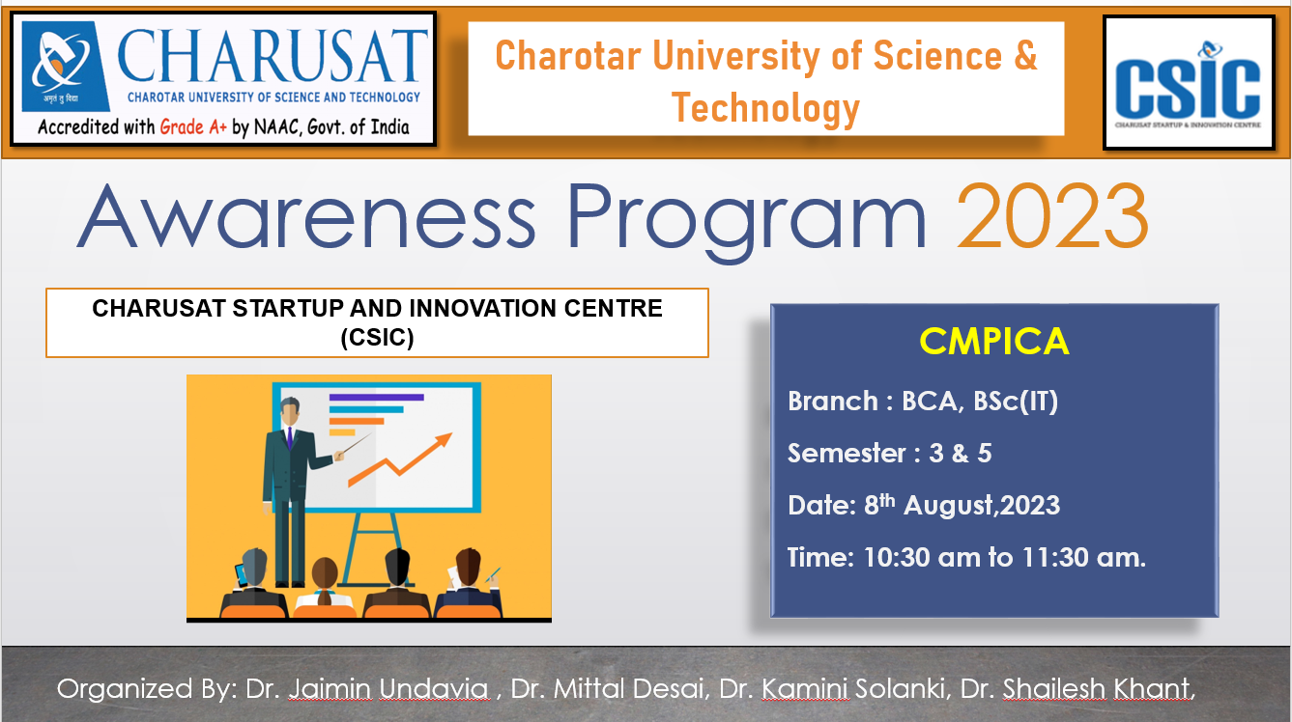

Summary of the

Awareness program Organized by CMPICA

Event Type: | CSIC Awareness program 2023
Title: | Awareness Program 2023
Topic: | Awareness about the CSIC cell, SSIP start up, iHub and business ideas.
Resource Person(s): (with designation, affiliation, email, phone number) | Dr. Jaimin Undavia  Dr. Kamini Solanki  Dr. Mittal Desai  Dr. Shailesh Khant
Duration: | 5 Hours (BCA, Bsc(IT), MCA, MSc(IT)
Funding from any Outside Agency: | NA
Targeted Audience: | BCA, Bsc(IT) semester 3 & 5
No. of Participants: | 279
Registration link | NA
Organizers: (Team Members) | Dr. Jaimin Undavia  Dr. Kamini Solanki  Dr. Mittal Desai  Dr. Shailesh Khant

Awareness Program 2023

8th August 2023

Report

Expert’s Name: - Dr. Jaimin Undavia
Dr. Kamini Solanki
Dr. Mittal Desai
Dr. Shailesh Khant

Brief Details of program: -

CHARUSAT aims to make its students Job Creators and not Job Seekers. In the context of the same, the University has established an eco-system for innovations including Incubation center and other initiatives for creation and transfer of knowledge named Entrepreneurship Development and Incubation Cell (EDIC) (2014).
It works with a vision to develop successful entrepreneurs who can contribute (to nation building) through creativity, problem-solving and innovation for the growth and development of society at large. EDIC aims to create an entrepreneurial ecosystem within CHARUSAT that acts as a catalyst in identifying, motivating and nurturing entrepreneurial talents; mentoring them towards sustainable pursuits through entrepreneurship awareness, education, training and research.
Entrepreneurship Developmental activities are being undertaken by faculty members trained at IIMA, University of Madras, EDI, University of Texas, USA and we also have access to renowned resource persons. For effective integration of entrepreneurship in all available disciplines within CHARUSAT, EDIC has identified Faculty Entrepreneurship Champions (FEC) from each department of the constituent departments / Institution through scientific tests.
Under the Student Startup and Innovation Policy (SSIP) initiated by Gujarat Knowledge Society, Commissionerate of Technical Education, Govt. of Gujarat, CHARUSAT EDIC has received / commitment for a grant of - Rs. 20 lakhs for next five years starting from 2017-18 onwards and the equal amount has been committed from CHARUSAT University. It has established Student Start-up and Innovation Cell (SSIP Cell) and Intellectual Property & Research Cell (IPR Cell). Under this, Establishment of State of Art Tinkering and Fabrication Laboratories with facilities like IoT, Electronic Equipment, 3D Printer Tools & Kits, Internet of Things & Sensors, Robotic Equipment, Microcontroller Boards, Development Boards, Robotic / DIY Kits is established at CHARUSAT.

Photographs of the Event
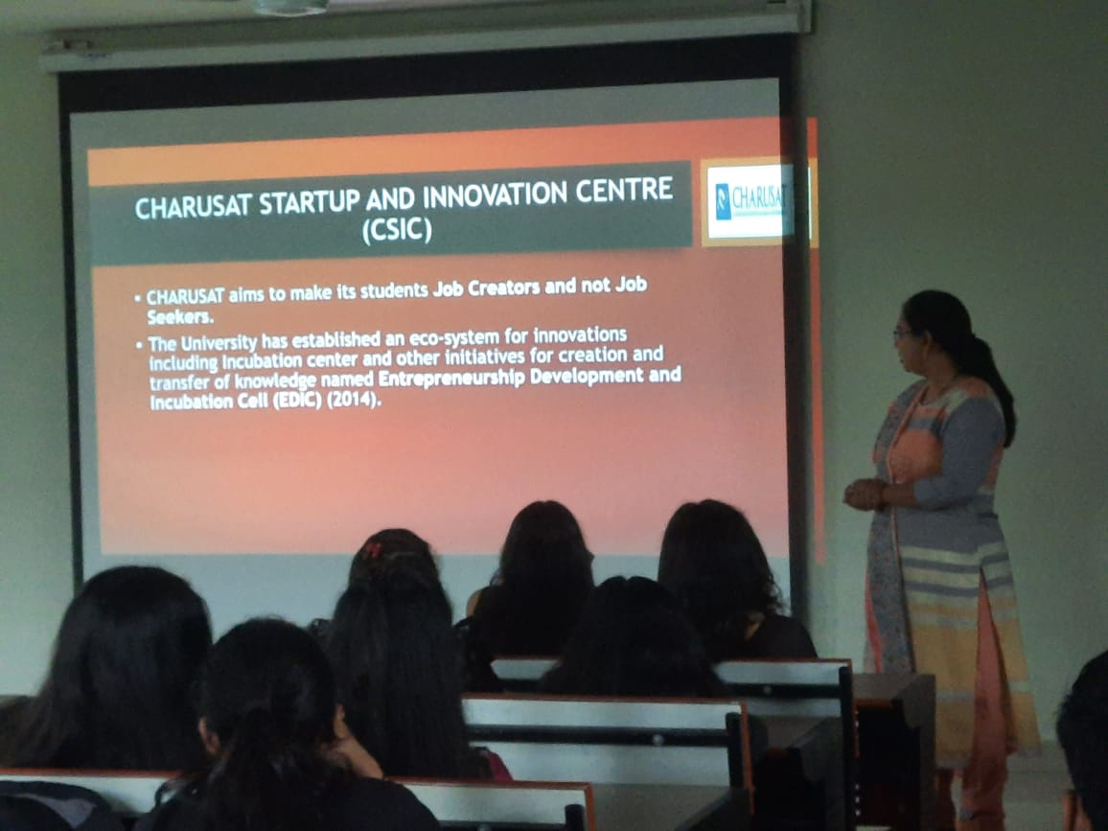 | 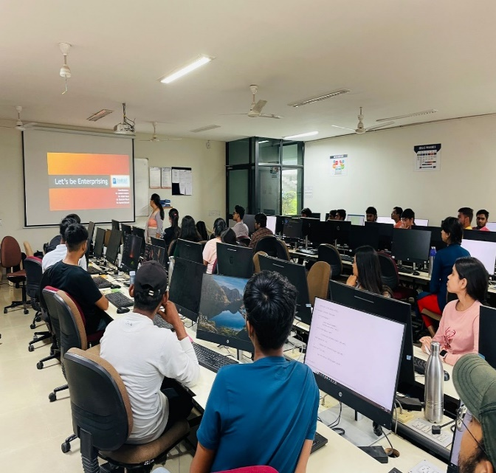
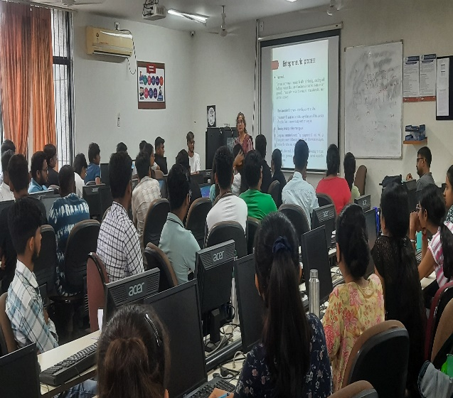 | 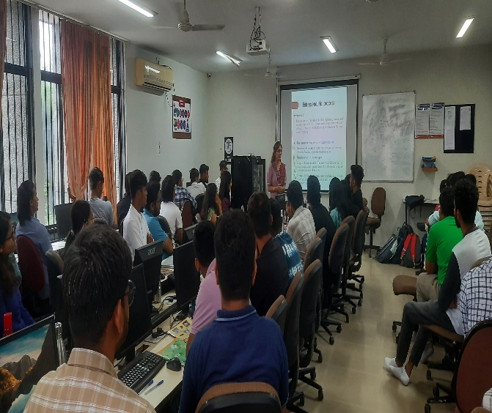

List of Present Students
Sr. No | Enrolment No | Name
1 | 21BCA001 | VAISHVI VAIDYA
2 | 21BCA002 | VISHNU PATEL
3 | 21BCA003 | KESHAVI KACHHADIYA
4 | 21BCA004 | KRISHNA DARJI
5 | 21BCA007 | JUHI KANSARA
6 | 21BCA008 | PRATHAM RATHOD
7 | 21BCA009 | HETVI DOBARIYA
8 | 21BCA010 | SANABEN VAHORA
9 | 21BCA011 | TANU CHOVATIA
10 | 21BCA013 | NANDANI DOBARIYA
11 | 21BCA014 | SNEHA PATEL
12 | 21BCA015 | BANSARI PATEL
13 | 21BCA016 | DEEP SONI
14 | 21BCA017 | DHRUV LAKHANI
15 | 21BCA018 | JANVI DEVANI
16 | 21BCA020 | PRANJALBEN PATEL
17 | 21BCA022 | TILAK VALAND
18 | 21BCA023 | KRISH BODARA
19 | 21BCA024 | UTSAV JADVANI
20 | 21BCA025 | MAHEKBEN GONDALIYA
21 | 21BCA026 | DISHA PATEL
22 | 21BCA027 | KRISHNA SAVERDEKAR
23 | 21BCA028 | DHRUVI PATEL
24 | 21BCA029 | VIVEK KAKAIYA
25 | 21BCA031 | KRINA SHAH
26 | 21BCA032 | MADHURI PAMECHA
27 | 21BCA034 | ABHIGNA MAHERIYA
28 | 21BCA035 | MINAXI PAMECHA
29 | 21BCA036 | ISHAN CHOVATIYA
30 | 21BCA037 | PRAPTI UPADHYAY
31 | 21BCA039 | KUSHAL RAJANI
32 | 21BCA045 | JAYKUMAR PATEL
33 | 21BCA046 | OM PATEL
34 | 21BCA049 | DISHABEN PATEL
35 | 21BCA050 | FORAMBEN KANANI
36 | 21BCA051 | SNEHABEN VAGHELA
37 | 21BCA052 | KHANJAN SANGHAVI
38 | 21BCA053 | ASHVI RANAPARIYA
39 | 21BCA054 | RUTVI NAROLA
40 | 21BCA058 | TISHA PATADIYA
41 | 21BCA059 | ANISH PATEL
42 | 21BCA060 | SRUSHTI NAKRANI
43 | 21BCA061 | DEV PATEL
44 | 21BCA062 | ANSHI TILVA
45 | 21BCA063 | DEVANSHU PATEL
46 | 21BCA065 | JEEL GADHESARIYA
47 | 21BCA066 | MAHIR BATTIWALA
48 | 21BCA067 | MOHAMMADMOINUDDIN SHAIKH
49 | 21BCA068 | VENSI DANKHARA
50 | 21BCA069 | HEER ASWANI
51 | 21BCA070 | VRUNDA PATADIA
52 | 21BCA071 | DHRUVI MATHUKIYA
53 | 21BCA072 | POOJA TALAVIYA
54 | 21BCA073 | SAHIL MANIYA
55 | 21BCA074 | KISHAN BHAGAT
56 | 21BCA076 | GARGI CHOKHALIYA
57 | 21BCA077 | VAIBHAV MAKWANA
58 | 21BCA078 | RONISH RAMOLIYA
59 | 21BCA079 | ARPAN MALAVIYA
60 | 21BCA082 | AAYUSHI MODI
61 | 21BCA085 | NAJUKBEN PATEL
62 | 21BCA086 | NIRAJ DHOKAI
63 | 21BCA087 | VIVEK TIWARI
64 | 21BCA088 | DEV SHAH
65 | 21BCA089 | ADITYA TRIVEDI
66 | 21BCA090 | VIKRANT SHARMA
67 | 21BCA092 | DIVYESH RAVAL
68 | 21BCA093 | SHUBHAM SHAH
69 | 21BCA094 | HEMAL AMIN
70 | 21BCA095 | DRASHTIBEN PATEL
71 | 21BCA098 | KRISH SAVANI
72 | 21BCA101 | MANAN DHAMELIYA
73 | 21BCA103 | KRISH PATEL
74 | 21BCA111 | TIYA PATEL
75 | 21BCA112 | AKSHAN KHANNA
76 | 21BCA114 | TISHA PATEL
77 | 21BCA115 | PREKSHA RADADIYA
78 | 21BCA117 | UMANG BHOJANI
79 | 21BCA118 | ARYAN SABHADIYA
80 | 21BCA121 | DEV DALAL
81 | 21BCA122 | CHARVIK NARIYA
82 | 21BCA123 | VAISHNAVI PRAJAPATI
83 | 21BCA124 | DHRUTIBEN PATEL
84 | 21BCA127 | NISHA PATEL
85 | 21BCA128 | DHRUMIL TRIVEDI
86 | 21BCA129 | SWAYAM SHAH
87 | 21BCA130 | DARSHAN PRAJAPATI
88 | 21BCA133 | JANVI PARMAR
89 | 21BCA135 | VRUSHANK PATEL
90 | 21BCA136 | JAY PAREKH
91 | 21BCA137 | KEVIN AKBARI
92 | 21BCA138 | PRINSU TALAVIYA
93 | 21BCA139 | DIYA DAVE
94 | 21BCA140 | VIDHIBEN PATEL
95 | 21BCA141 | DARSHAN BHATT
96 | 21BCA143 | SHIV PATEL
97 | 21BCA146 | OM PANCHAL
98 | 21BCA147 | VRUSHTI HADIYAL
99 | 21BCA148 | TAPANKUMAR PRAJAPATI
100 | 21BCA149 | KHUSHI POSHIYA
101 | 21BCA150 | NIYATI PATEL
102 | 21BCA151 | TIRTH THAKKAR
103 | 21BCA152 | ANIRUDDHSINH PADHIYAR
104 | 21BCA153 | KRUPAL GOLAKIYA
105 | 21BCA154 | SIDDHARTH RANA
106 | 21BCA156 | JANKI SHARMA
107 | 21BCA157 | HARSH KUMAR
108 | 21BCA158 | SANDEEPSINH CHAUHAN
109 | 21BCA160 | PULKITKUMAR THAKKAR
110 | 21BCA161 | CHINTAN KUMAR PANCHAL
111 | 21BCA163 | VRAJ PATEL
112 | 21BCA166 | AKSHAR JASOLIYA
113 | 21BCA167 | VAISHNAVI PATEL
114 | 21BCA168 | HITARTH BHATT
115 | 21BCA169 | RAJ PATEL
116 | 21BCA170 | NAMAN PATEL
117 | 21BCA171 | RASANGI PATEL
118 | 21BCA173 | MITALI RAMANI
119 | 21BCA177 | PRAYAG PATEL
120 | 21BCA178 | KRISH PATEL
121 | 21BCA180 | RISHIL SHAH
122 | 21BCA181 | DHAIRYA PAREKH
123 | 21BCA182 | PARTH PATEL
124 | 21BCA183 | ISHAN KAPATEL
125 | 21BCA184 | MANTHAN SHARMA
126 | 21BCA185 | KHUSHI SUKHADIA
127 | 21BCA186 | PRINCE NAVAPARA
128 | 21BCA188 | SHAKSHI PATEL
129 | 21BCA189 | SMIT SONI
130 | 21BCA190 | AKANXA PATEL
131 | 21BCA191 | RAJEEV
132 | 21BCA192 | RIDHAM SAVANI
133 | 21BCA194 | VEER VANANI
134 | 21BCA195 | MANAVSINH MAHIDA
135 | 21BCA197 | NAIYA PATEL
136 | 21BCA198 | PRUSHTI SHAH
137 | 21BCA199 | NIRMALKUMAR PATEL
138 | 21BCA200 | KHUSHANG KANSARA
139 | 21BCA202 | DHRUMIL ADESHARA
140 | 21BCA203 | ASHISH RANA
141 | 21BCA204 | DHARMIK PATEL
142 | 21BCA205 | YASH PURABIA
143 | 21BCA206 | HET PATEL
144 | 21BCA209 | DHRUV PATEL
145 | 21BCA211 | PRATHAM PATEL
146 | 21BCA212 | MEETKUMAR PATEL
147 | 21BCA213 | ARYANKUMAR PATEL
148 | 21BCA215 | KARAN THAKKAR
149 | 21BCA216 | SHREY SUKHADIYA
150 | 21BCA217 | AKSHAT SHAH
151 | 21BCA218 | DAX PRAJAPATI
152 | 21BCA220 | PREET KACHHIA
153 | 21BCA222 | MAHAMMAD SAJAD VHORA
154 | 21BCA223 | SHIVAM RAVAL
155 | 21BCA226 | DEVKUMAR PATEL
156 | 21BCA228 | PRUTHURAJ PARIKH
157 | 21BCA229 | DHRUV DODIYA
158 | 21BCA232 | TANVI PATEL
159 | 21BCA233 | NEMEE SHAH
160 | 21BCA234 | NANDANI PATEL
161 | 21BCA239 | AYUSH PATEL
162 | 21BCA241 | HET SHAH
163 | 21BCA243 | TULSI MAKWANA
164 | 21BCA245 | RITESHKUMAR PRAJAPATI
165 | 21BCA249 | HARIKUMAR PATEL
166 | 21BCA253 | VIVEK GANATRA
167 | 21BCA254 | HARSH PATEL
168 | 21BCA255 | ZEELBEN SHUKLA
169 | 21BCA256 | PRIYANSH DABHI
170 | 21BCA257 | DHRUVITKUMAR PATEL
171 | 21BCA258 | DHRUV DESAI
172 | 21BCA259 | DARSHAN PATEL
173 | 21BCA264 | DHARMIK PATEL
174 | 21BCA268 | DARSHAN SONI
175 | 21BCA272 | DHRUV PATEL
176 | 21BCA279 | RIYA PATEL
177 | 21BCA283 | JAYMIN DARJI
178 | 21BCA284 | MANAV THAKKAR
179 | 21BCA286 | SAMIR PATEL
180 | 21BCA287 | JIL PATEL
181 | 21BCA290 | KRISHIKUMAR PATEL
182 | 21BCA291 | HET PATEL
183 | 21BCA293 | TIRTH PATEL
184 | 21BCA294 | PRATHAM PATEL
185 | 21BCA295 | OM BAROT
186 | 21BCA296 | YANA SHAH
187 | 21BCA300 | MANN PATEL
188 | 21BCA306 | KUMAR RISHIKESH
189 | 21BSIT002 | JANVI DARJI
190 | 21BSIT005 | AVNI PANSHERIYA
191 | 21BSIT007 | TISABEN PATEL
192 | 21BSIT012 | DHRUV PATEL
193 | 21BSIT013 | DISHITKUMAR RATHOD
194 | 21BSIT015 | DITI PATEL
195 | 21BSIT016 | DEEP SAVALIYA
196 | 21BSIT017 | LUCKY RATHORE
197 | 21BSIT018 | AKASH BARVADIYA
198 | 21BSIT019 | VISHVA KUMBHANI
199 | 21BSIT020 | NIKHILKUMAR PANASARA
200 | 21BSIT023 | FENIL BHIMANI
201 | 21BSIT024 | PRASHANT VIROJA
202 | 21BSIT025 | KRISHNA SIMEJIYA
203 | 21BSIT026 | DHRUTI DHAMELIYA
204 | 21BSIT027 | DARSHAN CHAUHAN
205 | 21BSIT029 | TULSI PATEL
206 | 21BSIT031 | PANTH PATEL
207 | 21BSIT032 | KHUSHI MAKHANASA
208 | 21BSIT034 | SHRIYA VIRPARIA
209 | 21BSIT035 | YAMAN PATEL
210 | 21BSIT037 | VIVEK PRAJAPATI
211 | 21BSIT038 | VARUNSINH YADAV
212 | 21BSIT039 | POOJA SUTHAR
213 | 21BSIT040 | ANSH BHAVSAR
214 | 21BSIT041 | ALOKKUMAR YADAV
215 | 21BSIT043 | SONALI GAJJAR
216 | 21BSIT045 | SMIT KAVA
217 | 21BSIT046 | RITIK PATEL
218 | 21BSIT049 | NEEL PATEL
219 | 21BSIT052 | ARYAN VERMA
220 | 21BSIT054 | DISHA RAJPUT
221 | 21BSIT055 | ISHITABEN PATEL
222 | 21BSIT061 | PAL PATEL
223 | 21BSIT062 | GAURAV BHATT
224 | 21BSIT063 | KAMAL SHAH
225 | 21BSIT064 | HARDI NAIK
226 | 21BSIT065 | DHANISHKUMAR PADHIYAR
227 | 21BSIT066 | KHUSH PATEL
228 | 21BSIT067 | ROHITKUMAR VADLE
229 | 21BSIT069 | VANSH KACHHIA
230 | 21BSIT071 | RONAK PATEL
231 | 21BSIT074 | ARYAN BHAVSAR
232 | 21BSIT075 | MD MUFIZ MALEK
233 | 21BSIT076 | RAJIV SAVALIYA
234 | 21BSIT077 | RAHUL PARMAR
235 | 21BSIT079 | RITI PATEL
236 | 21BSIT080 | NISHITABEN PATEL
237 | 20BSIT128 | MOHAMMADJEESHAN MOMIN
238 | 21BSIT082 | HELLY PATEL
239 | 21BSIT083 | VRUNDA DHADUK
240 | 21BSIT084 | DHRUV SHAH
241 | 21BSIT086 | ARYAN PATEL
242 | 21BSIT087 | SHEETAL JAIN
243 | 21BSIT088 | UDAY ARIWALA
244 | 21BSIT090 | NIRMAL PATEL
245 | 21BSIT091 | HARSH SANKHAVARA
246 | 21BSIT092 | POOJABEN SONAGRA
247 | 21BSIT093 | KRUPABEN PATEL
248 | 21BSIT095 | SALONI CHOHALIYA
249 | 21BSIT097 | BHAGYA PATEL
250 | 21BSIT099 | HET SHUKLA
251 | 21BSIT103 | HET PANDYA
252 | 21BSIT104 | AYUSHI PATEL
253 | 21BSIT108 | AKSHAY SARKALE
254 | 21BSIT110 | NEEL GOYANI
255 | 21BSIT111 | YUGEN DESAI
256 | 21BSIT115 | DHAIRYA BHOYA
257 | 21BSIT118 | PRAPTI PATEL
258 | 21BSIT119 | KIRTAN PATEL
259 | 21BSIT120 | RAJ YADAV
260 | 21BSIT123 | KRISHN VYAS
261 | 21BSIT124 | DRASHTI PARMAR
262 | 21BSIT126 | PARAM CHOKSI
263 | 21BSIT127 | MANAV PATEL
264 | 21BSIT128 | ANAND BHATT
265 | 21BSIT132 | AAYUSH MACWAN
266 | 21BSIT134 | DARSHKUMAR PATEL
267 | 21BSIT136 | VIDHI PATEL
268 | 21BSIT139 | MANKUMAR PATEL
269 | 21BSIT140 | YASH PATEL
270 | 21BSIT141 | MANN PATEL
271 | 21BSIT142 | DEV SUTHAR
272 | 21BSIT144 | SHIVKUMAR PATEL
273 | 21BSIT146 | YASHKUMAR PATEL
274 | 21BSIT147 | DEVANSHU PANDYA
275 | 21BSIT150 | AMIT PRAJAPATI
276 | 21BSIT153 | JIGNESH BHOI
277 | 21BSIT155 | VEDANT MEHTA
278 | 21BSIT156 | VRAJKUMAR PANDYA
279 | 21BSIT158 | AYUSH PATEL

